Erro:ORA-12515

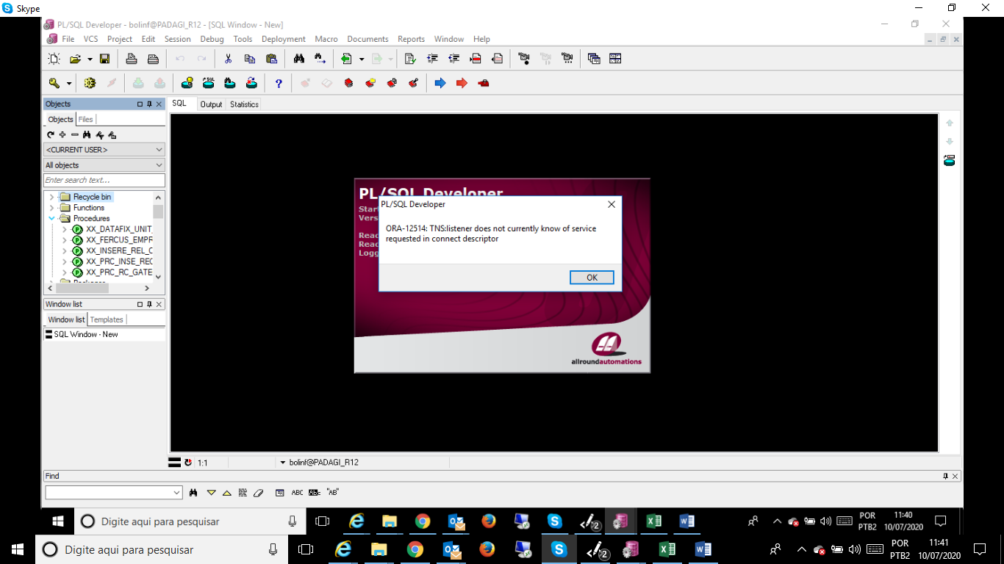

User = DB_INTEGRACAO

SENHA = inte4571

ORAGERAL_DC =

(DESCRIPTION =

(ADDRESS = (PROTOCOL = TCP)(HOST = 192.168.14.170)(PORT = 1521))

(CONNECT_DATA =

(SERVER = DEDICATED)

(SERVICE_NAME = ORAGERAL.adecoagro.brasil)

)

)